**中国的礼仪习俗**

**【写作任务】(Section B 3a＆3b)**

假如你是李华，你的美国笔友Mark要来中国学习一年，要寄宿在一个当地家庭。为了能很好地融入到寄宿家庭的生活中，他写信向你询问中国的礼仪习俗。请你根据要点提示给他写一封回信，从三个方面给他提一些建议。

要点提示：1. 吃饭时； 2. 在家时； 3. 约他人外出时。

**【思路点拨】**

**1. 定基调**

**体裁：**应用文(书信)；信的主体部分为说明文

**时态：**一般现在时

**人称：**回信主体内容是给别人提建议，所以应该以第二人称you为主。

**2. 谋布局、写句子**

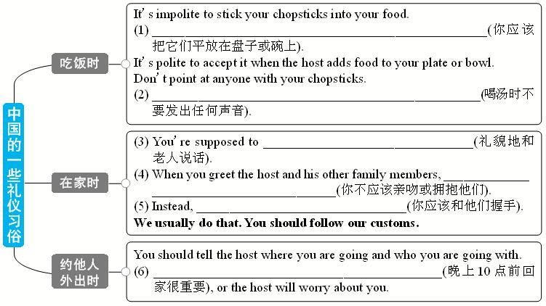

**3. 巧衔接**

(1) 使用平行结构(It’s ... to ... 和Don’t ...)能使文章节奏匀称，这是使文章衔接的一种方法。

(2) 词汇的重复(be supposed to)和同义词的使用(be supposed to, should)也是使文章衔接的一种方法。

**4. 成篇章**

Dear Mark,

You must be excited about coming to China soon. Let me give you some suggestions and advice about Chinese customs. When you’re eating at the table, it’s impolite to

In our house, you’re supposed to

When you go out with people, you should

Have a safe trip, and I look forward to meeting you soon!

Best wishes,

Li Hua

**5. 化“平凡”为“非凡”**

We usually do that. You should follow our customs. → When in Rome, do as the Romans do.

## 答案

2. 谋布局、写句子

(1) You’re supposed to / You should lay them on your plate or bowl

(2) Don’t make any noise when you eat your soup

(3) speak / talk to the old people politely

(4) you’re not supposed to / you shouldn’t kiss or hug them

(5) you’re supposed to / you should shake hands with them

(6) It’s important to come back home by 10:00 p.m.

4. 成篇章

Dear Mark,

You must be excited about coming to China soon. Let me give you some suggestions and advice about Chinese customs. When you’re eating at the table, **it’s** impolite **to** stick your chopsticks into your food. **You’re supposed to** lay them on your plate or bowl. **It’s** polite **to** accept it when the host adds food to your plate or bowl. **Don’t** point at anyone with your chopsticks. **Don’t** make any noise when you eat your soup.

In our house, **you’re** **supposed to** speak to the old people politely. When you greet the host and his other family members, you **shouldn’t** kiss or hug them. Instead, **you’re supposed to** shake hands with them. We usually do that. You **should** follow our customs.

When you go out with people, you **should** tell the host where you are going and who you are going with. **It’s** important **to** come back home by 10:00 p.m., or the host will worry about you.

Have a safe trip, and I look forward to meeting you soon!

Best wishes,

Li Hua